**Task 6 for submission**

*This task addresses the following unit objectives:*

***Unit Objective 5 – Synthesise and solve accounting problems relating to accounting and end-of-year reporting for a trading GST business.***

Deb Mailman is the owner of Smart-Tech, a business that sells computer supplies and services.

As Deb’s bookkeeper, you are required to:

1. apply transaction analysis, double entry principles and accounting processes to record all financial transactions for the month of June 2017 in the general journal;
2. **synthesise** the data and information to determine:
   * the end-of-month cash at bank balance
   * the amount of GST owed to the ATO

**OPENING ACCOUNT BALANCES AS AT 1 JUNE 2017:**

|  |  |
| --- | --- |
| Accounts payable: |  |
| Comp Ltd | 12,600.00 |
| Accounts receivable: |  |
| C Jones | 2,840 |
| S Robertson | 2,000 |
| Bank | 65,810.30 |
| Vehicles | 15,500 |
| Inventory | 42,860 |
| GST collected | 2,429.90 |
| GST credits received | (1869.70) |
| Loan from CARQ Bank | 50,000 |
| Shares – NAQSAT Ltd | 70,000 |

**COST PRICES OF INVENTORIES:**

|  |  |
| --- | --- |
| Desk top hard drives | $115 |
| Portable hard drives | $75 |
| Network attached storage | $150 |
| Webcams | $32 |
| Privacy filters | $100 |
| Computer cleaners | $35 |
| Acer Aspire Pentium | $225 |
| Panda convertible laptop | $135 |

**TAX INVOICES RECEIVED:**

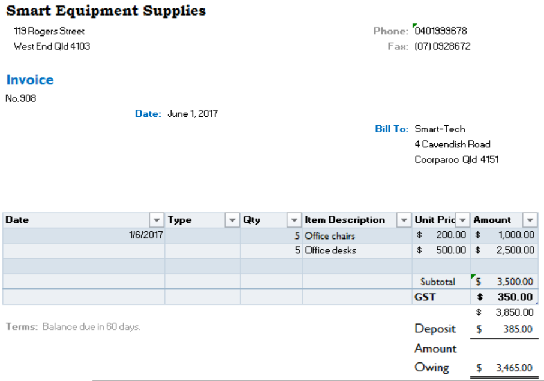

**Tax Invoice** No. 908

**ABN 87 454 990 555**

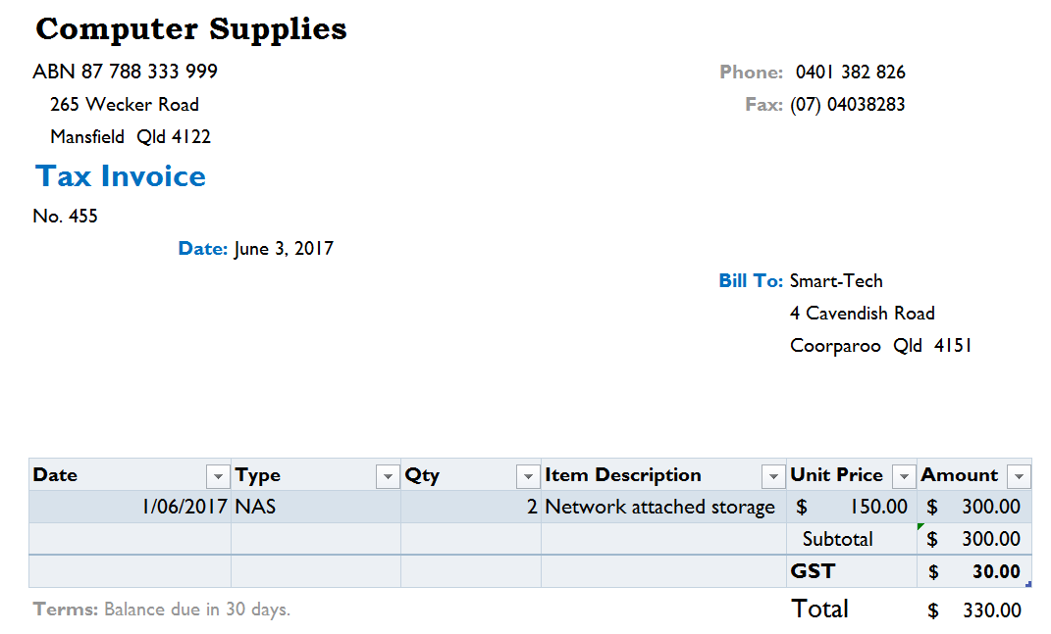

**CASH REGISTER SUMMARIES:**

Smart-Tech

**ABN: 87 522 653 744**

4 Cavendish Road, COORPAROO QLD 4151

Tax Invoice

4/6/2017

6 Acer Aspire Premium $2700*

2 Portable hard drives $300*

Total $3000

Paid cheque (K Olive) $3000

*Total includes $272.73 GST*

Smart-Tech

**ABN: 87 522 653 744**

4 Cavendish Road, COORPAROO QLD 4151

Tax Invoice

2/6/2017

Computer upgrade service $640

Total $640

Paid cash $640

*Total includes $58.18 GST*

**COPIES OF INVOICES ISSUED:**

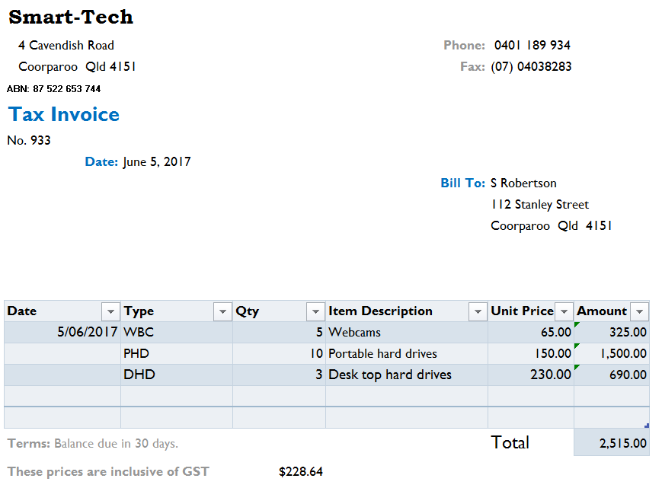

**CHEQUE DETAILS:**

Date: 6/6/2017

To: Fay White Real Estate

For: Rent

Bal. B/F:

Deposit:

Balance:

This chq: $1650

Bal C/F:

**ADDITIONAL INFORMATION:**

***8 June:***

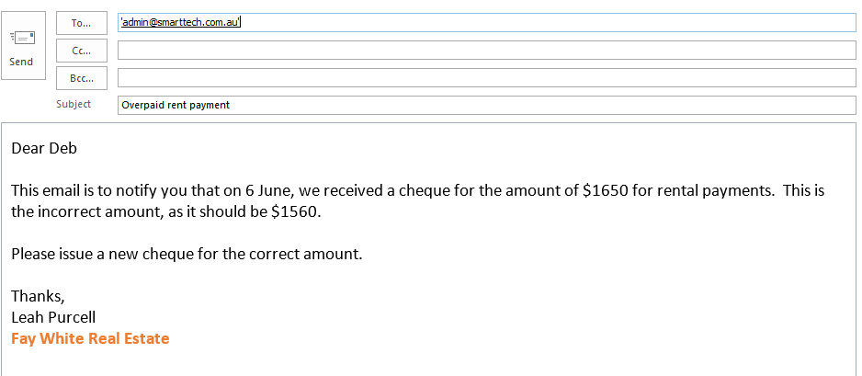

The owner, Deb Mailman has identified a number of other transactions that need to be recorded:

|  |  |
| --- | --- |
| 2 June | Deb took home one desktop hard drive to back up some personal data $115 |
| 7 June | Returned faulty stock (1 Network Attached Storage) to Computer Supplies purchased on 3 June |
| 8 June | Issued a new cheque to Fay White Real Estate - *see email above* |